Instructions for Travel Exhibition Crate
Tools Needed:
- Chuck or Impact Drill
- ½ inch Hex socket bit
- Philips head socket bit
- 2 handlers

Unpacking the Crate
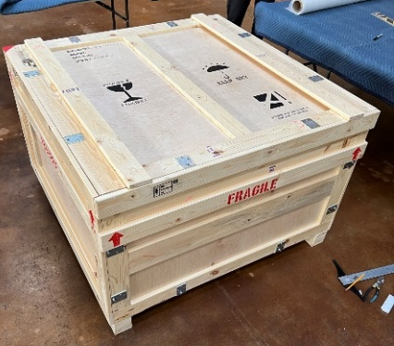
- Use drill with Hex socket bit to remove bolt-down lid on top first

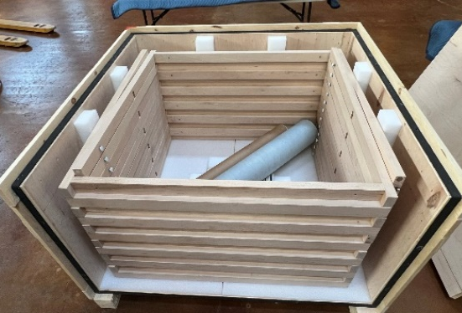
- Using the same drill remove only 1 of the side panels of the crate
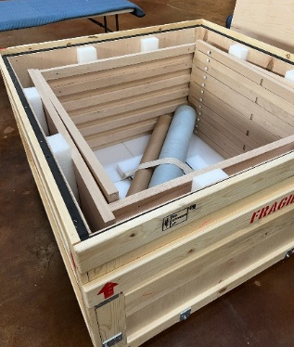

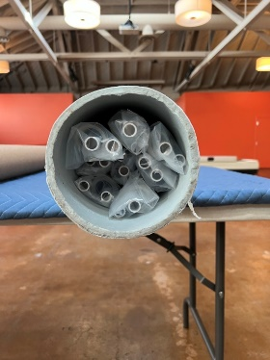
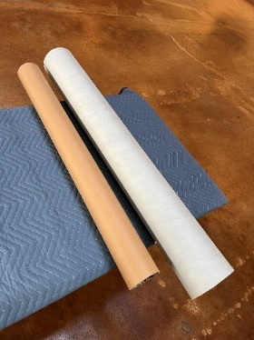
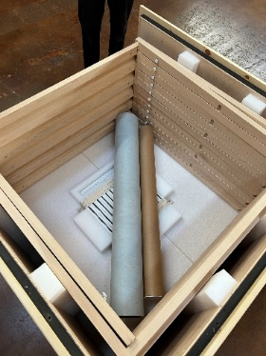
- Looking down into the crate you’ll see (2) Tubes containing all the rolled-up vinyl exhibition material. Remove the tubes and one handler can start unwrapping the vinyl.
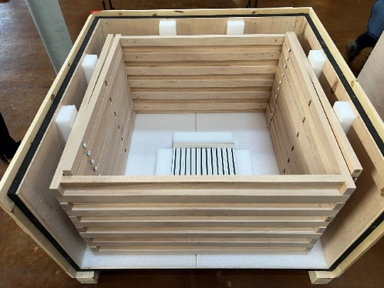
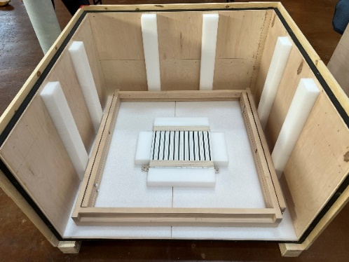
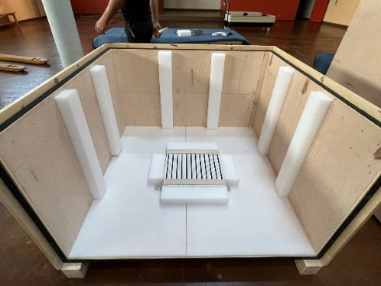
- The other handler can remove the exhibition frames one-by-one

- The bases for each frame are secured at the bottom of the crate. That can be removed by undoing the straps and pulling them out.
The brackets for holding the exhibition frames are also included and fitted into a cut out section of the foam.
